Assignmet 24

sudo apt install docker
docker login
username
PASS
nano docker-compose.yml

put this text in nano

version: '2.1'
services:
ftp:
image: delfer/alpine-ftp-server
network_mode: host
# ports:
# - 21:21
# - 21000-21010:21000-21010
environment:
- USERS=one|1234|/home/one|10000 two|1234|/home/two|10001
volumes:
- ./one:/home/one
- ./two:/home/two

sudo docker compose -d
sudo docker-compose ps

download filezilla
sudo add-apt-repository ppa:xtradeb/apps
sudo apt install filezilla

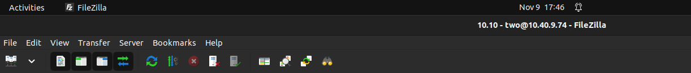
click on symbol below file

get ip of yoy pc
ifconfig

put that ip in

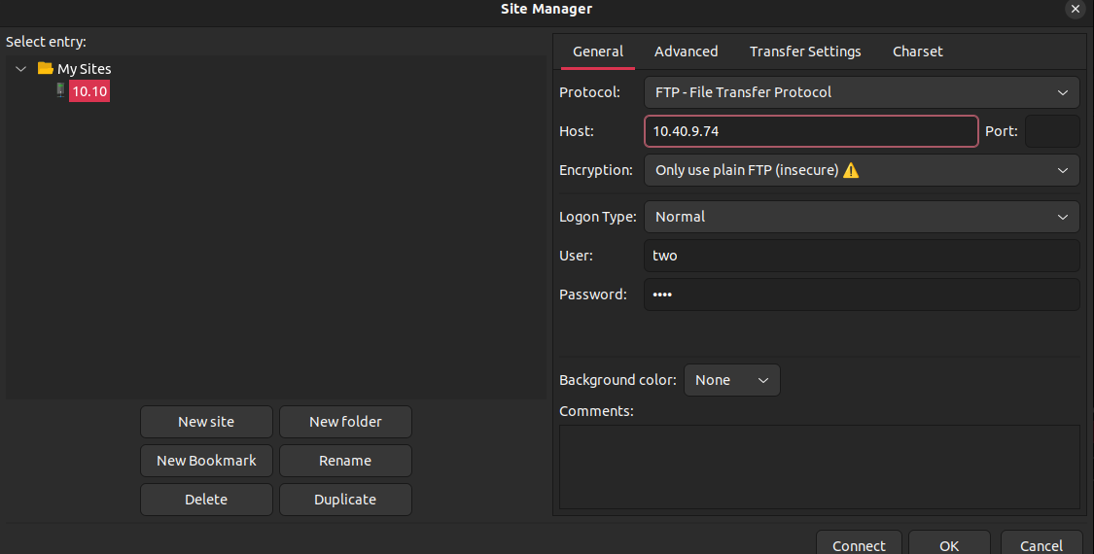
put ip in host port 21
user as two pass 1234
click ok

now done

